Case Oceania-Philippines-Ifugao-Spoon-*Anito*-Wood-19th c

**Case no.:**

**Accession Number: A000**

**Formal Label:** Philippines-Ifugao-Igorot-Bulul Figure-Androgynous-Wood-15th cent.

**Display Description:**

Northern Luzon’s central cordillera is home to indigenous communities called the Ifugao or Igorot whose self-determination and geographic isolation helped protect them from Spanish colonization. The term "Ifugao" or "*ipugo*" means "earth people," "humans," as distinguished from sky-dwelling spirits and deities. However, the Austronesian term "Igorot" ("mountain people") is more correct an appellation, as these people are all Austronesian speakers. Furthermore, the Igorot divide themselves into two subgroups: a rice terrace-farming group in the south, central and western areas, and a smaller group in the east and north (Ember and Ember 2003: 498). These two Igorot groups may be further subdivided into five Igorot ethnolinguistic groups: Bontoc, Ibaloi, Isnag, Kalinga, and the Kankanaey (Anon. 2015)

The traditional Ifugao believe their lives were ruled by spirits called *anitos*. During a curing ritual the Ifugao shaman in a trance ascends to the sky-world to retrieve the ancestral *anitos* and the offending *anitos*. The *anitos* from his clan are believed to speak through him as a medium so that the ancestors can speak to their living relatives. He offers rice beer in wooden spoons to these ancestral *anitos* who are carved on these wooden spoons whom he invokes to help cure the disease. As the shaman swallows the rice beer from the wooden spoon, it is believed that the ancestors are drinking the rice beer through the shaman’s mouth. The shaman also offers rice beer in these wooden spoons to the offending *anitos* who are also believed to drink the beer from the shaman’s mouth. The ancestors thus contacted were believed to counter the offending *anitos* with their imprecations. These spoons were used in these ceremonies in the 19th c as Spanish priests were trying to put an end to these animistic practices.

Since the Ifugao shaman ascends the upper world to contact the *anitos* it is believed by traditional Ifugao that the universe is divided into five levels. At the top is: 1) the heavens which itself has four levels. Beneath it is 2) Pugao, the known land. Below Pugao is 3) the underworld and there is also 4) the world upstream and 5) the world downstream. Igorot cosmology views each village with its own axis mundi, a central stone platform linking it to the deities above. This central platform provides the focus for social and spiritual rituals, including the worship of deities and ancestors and the consecration of sculptural figures like this one. Kiyyangan is considered the birthplace of the Igorot people and Hungduan as the epicenter of its culture.

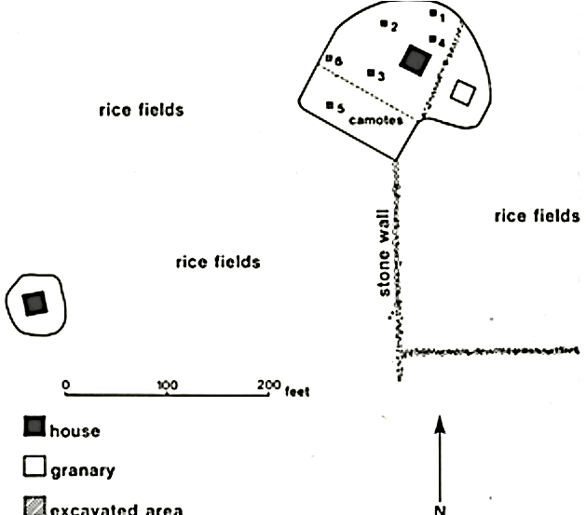

Fig. 5. Kiyyangan village excavations. From (Maher 1984).

**LC Classification:** DS666.I15

**Date or Time Horizon:** 15th century

**Geographical Area:** Hungduan, Luzon, Philppines

**Map:**

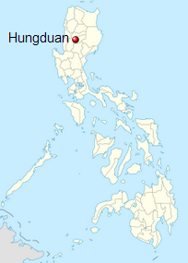

Fig. 6. Location of Hungduan in Luzon, Philippines. From https://upload.wikimedia.org/wikipedia/commons/thumb/a/ad/Philippines_location_map_%28square%29.svg/375px-Philippines_location_map_%28square%29.svg.png

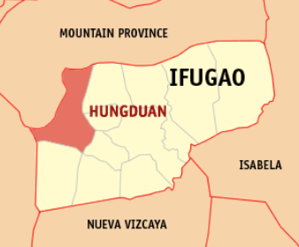

Fig. 7. Location of Hungduan village in its surrounding area. From https://upload.wikimedia.org/wikipedia/commons/e/eb/Ph_locator_ifugao_hungduan.png

**GPS coordinates:** [16°50′N 121°00′E](https://tools.wmflabs.org/geohack/geohack.php?pagename=Hungduan,_Ifugao&params=16.83_N_121_E_region:PH_type:city%289400%29)

**Cultural Affiliation:** Ifugao, Igorot

**Media:** wood, swine blood

**Dimensions:** H 25.4 cm, 10 in

**Weight: 853 g, 1 lb 14 oz**

**Condition: original**

**Provenance:** old Spanish collection

**Discussion:**

The Igorot developed one of the most sophisticated and prosperous plutocracies in the Philippine archipelago, and, with Kalinga, it was one of the two most important plutocracies in Luzon.

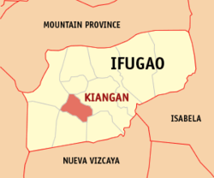

Fig. 8. Location of Kiangan (inside of which is Kiyyangan) in its surrounding area. From <https://upload.wikimedia.org/wikipedia/commons/c/c5/Ph_locator_ifugao_kiangan.png>

Kiyyangan is considered the most ancient village of the Igorot and the birthplace of the Igorot people where their mythological ancestors Wigan and Bugan had originated. However, the TL (thermoluminescent) dating of excavated pottery from the site is from the 13th century CE, so that earlier remains must have been obliterated with each succeeding occupation (Maher 1984: 127).

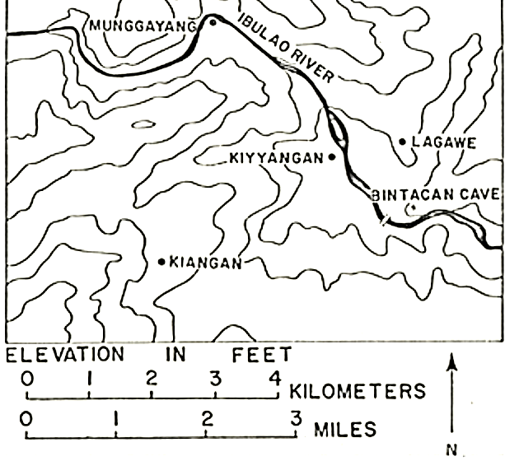

Fig. 9. Location of Kiyyangan. From (Maher 1984).

The country of the Igorot in the southeastern part of the Cordillera region are known for their Banaue Rice Terraces that were first constructed about 500 BCE and are among the most efficient agricultural technologies of volcanic islands in the western Pacific. These terraces are where the *bulul* are placed, so that sometimes the *bulul* become submerged in the soil due to erosion of the terraces and become exposed only years later with further erosion, like the current example and this is why it is in such good shape.

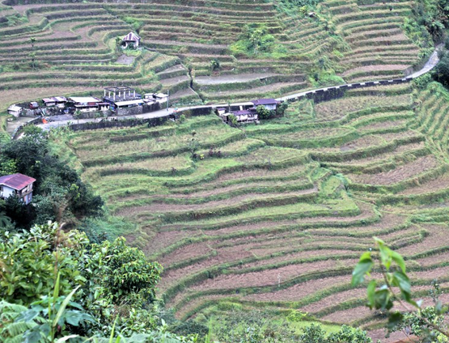 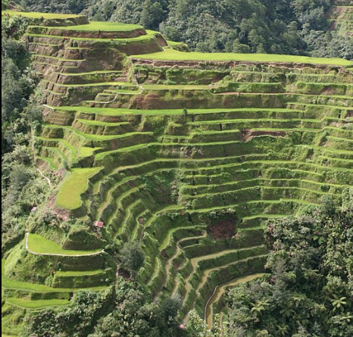

Fig. 10. Banaue rice terraces (N. Luzon, Philippines). From <https://i2.wp.com/harrybalais.com/wp-content/uploads/2014/10/Hungduan-Rice-Terraces-01.jpg?resize=1024%2C683>

Fig. 11. Banaue rice terraces (N. Luzon, Philippines) taken from the observation point at beginning of road to Bontoc. Clear evidence of erosion of the terraces. From https://upload.wikimedia.org/wikipedia/commons/thumb/c/cc/Banaue-terrace.JPG/1200px-Banaue-terrace.JPG

The Igorot villages are ruled not by monarchs but by a council of elders which continued a peaceful and prosperous plutocracy that resolved conflicts among the Igorot people and the lowland settlers or Ilokanos.

**References:**

Anon. 2015. http://sagada-igorot.blogspot.com/2007/12/igorot-ethnic-groups.html

Ember, Carol R. and Melvin Ember. 2003. [*Encyclopedia of sex and gender: men and women in the world's cultures*, Volume 1](https://books.google.com/books?id=XUAsskBg8ywC&lpg=PA498&dq=Ifugao&pg=PA498#v=onepage&q=Ifugao&f=false). London: Springer.

Maher, Robert F. 1984. “Kiyyanga village of Ifugao Province, Philippines,” *Philippine Quarterly of Culture and Society*, 12(2): 116-127.

Willcox, Cornélis De Witt. 1912. *The head hunters of northern Luzon: from Ifugao to Kalinga, a ride through the mountains of northern Luzon: with an appendix on the independence of the Philippines.* New York: Franklin Hudson Publishing Co.

Each area has a large number of *anitos*, each of which has a name and belongs to one of 35 categories. Among them are ones associated with hero ancestors, diseases, omens, messengers, celestial bodies.

 There are around 1,500 important spirits. They have precise locations in the Ifugao universe that carry with them specific roles and duties. They cover almost of every aspect of life: war, peace, fishing, weaving, rain, disease and so on. In addition to spirits there are deities who are immortal and have the power to change form. There is no one supreme god which has made it easy for the Ifugao to accept Christianity and not have the Christian god in competition with the spirits of their traditional religion. [Source: "Vanishing Tribes" by Alain Cheneviére, Doubleday & Co, Garden City, New York, 1987**]

 F. Jagor wrote in “Travels in the Philippines” (1875): “The *anito* of the Philippines is essentially a protecting spirit.” The Spaniard Pardo de Tavera wrote in in 1906: “The religion of the islands, what may be called the true religion of Filipinos, consisted of the worship of the *anitos*. These were not gods, but the souls of departed ancestors, and each family worshipped its own, in order to obtain their favorable influence.” According to the De Morga the *anito* was a representation of the devil under horrible and frightful forms, to which fruits and fowl and perfumes were offered. Each house had and “made” (or performed) its *anitos*, there being no temples, without ceremony or any special solemnity. “This word is ordinarily interpreted ‘idol,’ although it has other meanings. There were *anitos* of the mountains, of the fields, of the sea. The soul of an ancestor, according to some, became embodied as a new *anito*, hence the expression, ‘to make *anitos*.’ Even living beings, notably the crocodile, were regarded as *anitos* and worshiped. The *anito*-figura, generally shortened to *anito*, ... was usually a figurine of wood, though sometimes of gold.”

**Ifugao Creation Myth**

 According to the Ifugao creation myth, the Ifugao gods created the heavens and earth way before they created man. When men were finally created most for the Gods had no interest in them and the patient god Wigan-i-abunyan was told he watch of them. The first men were ill suited for their environment and Wigan-i-abunyan sent his son Kagibat down to earth to show man how to use fire and build houses. When he returned he was so enthusiastic about what he saw that his sister Bugan descended to earth to teach men how to use the forces of air and water. Her report was equally glowing as that of Kagibat. Soon Kabunyan, the God of the Sun, Stars and Sky wanted to visit earth and see what all the fuss was about. But, from his vantage point in the sky he couldn't see anything so he moved in closer. With the sky so close to the earth, men had to hunch over and soon they couldn't even work. The nearness of the sun caused rivers to dry up and the crops to burn up. [Source: "Vanishing Tribes" by Alain Cheneviére, Doubleday & Co, Garden City, New York, 1987**]

 At this time the world still part of heaven. Mankind was having such a hard time they tried to tell Kabunyan to go away, but he couldn't understand their language. Finally an old woman who was so short she could stand up without having to hunch over started to mash some rice with a mortar and pestle. The pestle hit Kabunyan on the upswing to which god replied if you do that again I'm going to leave. The woman was deaf and because she could hear him she did hit him again. Kabunyan was annoyed by this he returned to heaven. The people were happy the sun and sky had returned to their normal position and from then on the sky and the earth have always been separated.**

**Ifugao Religious Ceremonies**

 A great deal of Ifugao resources are devoted to religious ceremonies that are invoked for agriculture abundance, hunting success, augury and good omens. As many as 15 priests may be involved ins a single ceremony. Well versed in Ifugao myths, they perform the important rituals and tell the myths. During the myth dramas the priest often utter an unintelligible hum for as long as five hours. It is not usual for a half dozen pigs, one buffalo and scores of chickens to be scarified during a ceremony.

 Ifugao priests preside over ceremonies and are believed have the power to influence the gods into performing earthly chores. There is no organized priesthood. It said that any tribe member with a good memory can perform the rituals. Priests attain their position voluntarily after a period of apprenticeship. They receive some compensation for their work but generally have other jobs. Their primary duty is to invoke spirtis of deceased ancestors and deities.

 The Ifugao believe that illnesses are caused by deities taking souls in cooperation with ancestors. Priests treat illnesses through divination and curing rituals. in an effort to get the deity to return the souls. If the priests fails, the Ifugao believe, the person dies.

Ifugao was a massive highland plutocracy, among the most sophisticated and prosperous of its kind in the whole archipelago and one of the two grandest highland plutocracies in Luzon, the other being the Plutocracy of Kalinga. The state existed for over 2,000 years and have built massive rice terraces that would be a symbol of the province in later time. There were no monarchs in the state. The state was ruled by its council of elders which led the state into a peaceful and prosperous plutocracy which developed one of the best agricultural technologies in Asia at its time. The state consisted of various subgroups which had similar yet somewhat distinct culture and traditions. Conflicts among the [Ifugao people](https://en.wikipedia.org/wiki/Ifugao_people) were resolved in the most peaceful way possible. Unlike most of the highland plutocracies in the Cordilleras at the time, the Plutocracy of Ifugao had the least conflict with lowland settlers. [Kiangan](https://en.wikipedia.org/wiki/Kiangan" \o "Kiangan) was known as the birthplace of the Ifugao people and [Hungduan](https://en.wikipedia.org/wiki/Hungduan" \o "Hungduan) as the epicenter of its culture.

